CPQ UI: UX update & CSS Themes

# Applies To:

Oracle CPQ Cloud –RefApp Enhancements

# Purpose

The following information will aid in updating our RefApp packages to improve UX and aesthetics.

# Details

## What are the available RefApp Themes?

Oracle CPQ Cloud introduces four new and improved UI options. These are intended to provide our sales demo teams and customers with clean, consistent starting points for their CPQ implementation. The four packages are based off three of our most popular integration scenarios, and the fourth is based on Oracle’s upcoming, new design styling.

1. JET Alta: Based on JET default look from version 6. Also known as Alta. OSC’s default look (aka Vanilla).
2. SFLightning: Based on Salesforce Lightning, not the classic SF Desktop look.
3. MSDynamics: Based on MS Dynamics styling.
4. Redwood: Oracle’s upcoming new design standard.

## What is included?

Each CSS Theme package contains the following:

1. Homepage: (sitename_HP_Alt.css, XSL and JavaScript. Note: XSL and JavaScript are from the Quickstart Blue package and are identical across all of the themes)
   1. Login screen with and without Guest Access, identical across all themes.
   2. Homepage based off the new Accessibility compliant structure, customized styling for each theme.
2. Navigation: (sitename_Alt_Nav.css)
   1. Alta navigation with theme specific styling
   2. Menu settings implemented with links in the best practice display arrangement.
   3. Instructions for activating Alta navigation and optimal menu configuration.
   4. Menu settings will be identical across all themes and should be part of the RefApp default setting.
3. Legacy UI:  (sitename_alt.css)
   1. Theme specific styling for Buyside Legacy UI; Configuration, Transaction Manager and Transaction.
   2. Config CSS will be included to insure that arrays and image menus in config are styled according to the theme.
4. JET UI: (JET CSS file)
   1. Theme specific styling for all JET UI, Commerce and Config (when released).
   2. JET Transaction enabled and set as default UI for all users. Layout modified from the Legacy UI to create an optimal User Experience and best demo starting point.
5. Image files:
   1. A zipped file with all necessary images for the theme, example: button icons, disclosure icons, logo, background, etc.

## What do I need to do for the Navigation menu settings?

All of the RefApp packages are intended to use the new Alta navigation menus. The _Alt_Nav.CSS file included improves sizing and margins of the Global Navigation Header, in order to upload this file one of the Legacy navigation menu options (Top or Side) must be set so that the Edit Stylesheet button is available. After this CSS file is uploaded, the Alta Navigation option can be set.

The Alta Navigation setting ignores content in the Header HTML. Any scripts or content that is needed to remain functional needs to be moved to the HTML Head. From Admin Homepage, click “Header & Footer”. Check the box to enable Use HTML Head”. Cut and paste any desired content from the center box of Header HTML into the top box of HTML Head. Click Accept to save this change.

For best results, the menu settings should be set up to place links in specific configurations to provide admin users and sales users with optimal user experience as follows:

1. Admin
   1. Admin User menu settings. Apply these settings to the following CompanyType:UserTypes:
      * 1. FullAccessWithESales: FullAccess
        2. BuyAccess: FullAccess
        3. QuickRegistrationBuy: FullAccess
        4. RestrictedAccess: FullAccess
      1. Left:
         1. (None)
      2. Center:
         1. Users (Internal)
         2. Data Tables (Internal) (If available)
         3. Company Information (If available)
      3. Right:
         1. (None)
   2. Non-Admin User menu settings. Apply these settings to the following CompanyType:UserTypes:
      * 1. FullAccessWithESales: SalesAgent
        2. FullAccessWithESales: ChannelAgent
        3. FullAccessWithESales: RestrictedAccess
        4. BuyAccess: BuyAccess
        5. BuyAccess: RestrictedAccess
        6. QuickRegistrationBuy: QuickRegistrationBuy
        7. QuickRegistrationBuy: RestrictedAccess
        8. RestrictedAccess: RestrictedAccess
      1. Left:
         1. (None)
      2. Center:
         1. (None)
      3. Right:
         1. Accounts (Internal) (If available)
2. Commerce
   1. All User types:
      1. Left:
         1. (Primary Commerce Process) – Manager (If available)
         2. (Primary Commerce Process) – Reporting (If available)
      2. Center:
      3. Right:
         1. (Additional Commerce Process) – Manager (If available)
         2. (Additional Commerce Process) – Reporting (If available)
3. Quick Registration
   1. RestrictedAccess: RestrictedAccess and NotLoggedIn: NotLoggedIn
      1. Left:
         1. Home Page (Internal)
      2. Center:
      3. Right:
   2. All other user types: No visible links, all Hidden.
4. Subheader
   1. Admin User menu settings: Apply these settings to the following CompanyType:UserTypes:
      * 1. FullAccessWithESales: FullAccess
        2. BuyAccess: FullAccess
        3. BuyAccess: RestrictedAccess
        4. QuickRegistrationBuy: FullAccess
        5. QuickRegistrationBuy: QuickRegistrationBuy
      1. Left:
         1. Home (Internal)
         2. Admin (Internal)
      2. Center:
         1. (None)
      3. Right:
         1. Pending Configuration (Internal)
         2. My Profile (Internal)
         3. Help (Internal)
         4. Partner Login (Internal)
         5. Proxy Logout (Internal)
         6. Log out (Internal)
   2. Sales User menu settings: Apply these settings to the following CompanyType:UserTypes:
      * 1. FullAccessWithESales: SalesAgent
        2. FullAccessWithESales: RestrictedAccess
        3. BuyAccess: BuyAccess
        4. BuyAccess: RestrictedAccess
      1. Left:
         1. Home (Internal)
         2. Admin (Internal)
      2. Center:
         1. (None)
      3. Right:
         1. Pending Configuration (Internal)
         2. My Profile (Internal)
         3. Proxy Logout (Internal)
   3. Chanel/Partner User menu settings: Apply these settings to the following CompanyType:UserTypes:
      * 1. FullAccessWithESales: ChannelAgent
        2. FullAccessWithESales: RestrictedAccess
        3. BuyAccess: BuyAccess
        4. QuickRegistrationBuy: QuickRegistrationBuy
        5. QuickRegistrationBuy: RestrictedAccess
      1. Left:
         1. Home (Internal)
      2. Center:
         1. (None)
      3. Right:
         1. Pending Configuration (Internal)
         2. My Profile (Internal)
         3. Partner Login (Internal)
         4. Proxy Logout (Internal)
         5. Log out (Internal)
   4. RestrictedAccess: RestrictedAccess
      1. Left:
         1. Home (Internal)
      2. Center:
         1. (None)
      3. Right:
         1. Help (Internal)
   5. RestrictedAccess: FullAccess and NotLoggedIn: NotLoggedIn
      1. No visible links, all Hidden.
5. Subfooter
   * 1. No visible links, all Hidden.

## What do I need to do for the Homepage?

From the Admin homepage, click the link for “Home page” to enter Home Page Setup. From here, click “Define XSL Templage”. Click Browse to select the following files for:

1. Production XSL File: production.xsl
2. Internal Test XSL File: internal.xsl
3. Alternate Stylesheet: (themename)_HP_Alt.css
4. Alternate Javascript File: homepage.js

## How do I apply the other CSS files?

The custom CSS file must be uploaded on the Stylesheet administration page. From the Admin homepage, navigate to “Stylesheet” in the Style and Templates section. Click Browse to upload the (themename)_Alt.css as the “Alternate CSS File”. Click Browse to upload the (themename)_JETUI.css as the “JET CSS File”.

## What do I need to do for the JET UI?

These packages are all intended for use with JET UI for the Transaction and for Configuration when available. These must be enabled and set as default.

When modifying the layouts for these UI, these are the recommended best practices:

* Design the layout for wide screens, let the responsive behavior adapt the content for smallers screens. Use 3-5 columns of form inputs when possible.
* Use toolbars with labels for Sub-headers inside panels, move any buttons from content area to these toolbars.
* Move all Line Item table related actions into the Line Item table specific toolbar.
* Use custom class “chartcol” to create fixed columns as needed.
* Modify labels in the Layout Editor to keep them brief and clear.
* Set default widths for Line Item table columns, especially for columns with a large amount of content or long labels.

## What else do I need to do?

Navigate to the File Manager. Create or navigate to the “images” folder. Click browse to upload the images.zip file, this will add or update all necessary images to the images folder.

Layout Updates for JET

1. Set Layout name to “CPQ Transaction”
2. Set Transaction panel to Plain Display
3. Add a new tab for Approvals
4. Rename Customer Details tab to Customer Info
5. Rename Pricing Details tab to Pricing
6. Rename Troubleshooting and Support Controls tab to Troubleshooting & Support
7. Delete toolbar below the LIG, add buttons to LIG toolbar, label as follows:
   1. “Add”: addLineItem_t
   2. “Remove” _remove_transactionline
   3. “Update” _update_line_items
8. Line Item Table setup:
   1. Set width of Product # column to 200px, set as link to Line Detail.
   2. Set labels and widths as shown here:

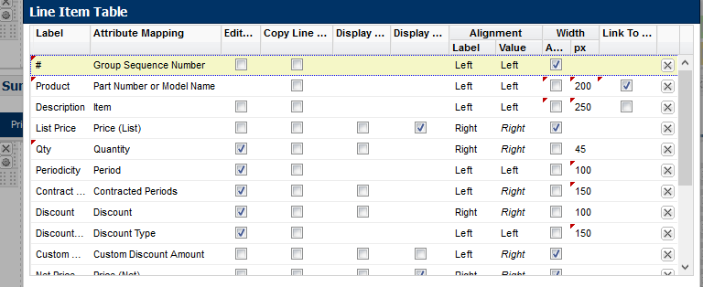

1. Recommended Layout example. Add columns, resize columns, create panels, rename labels and re-arrange as shown in the images below:

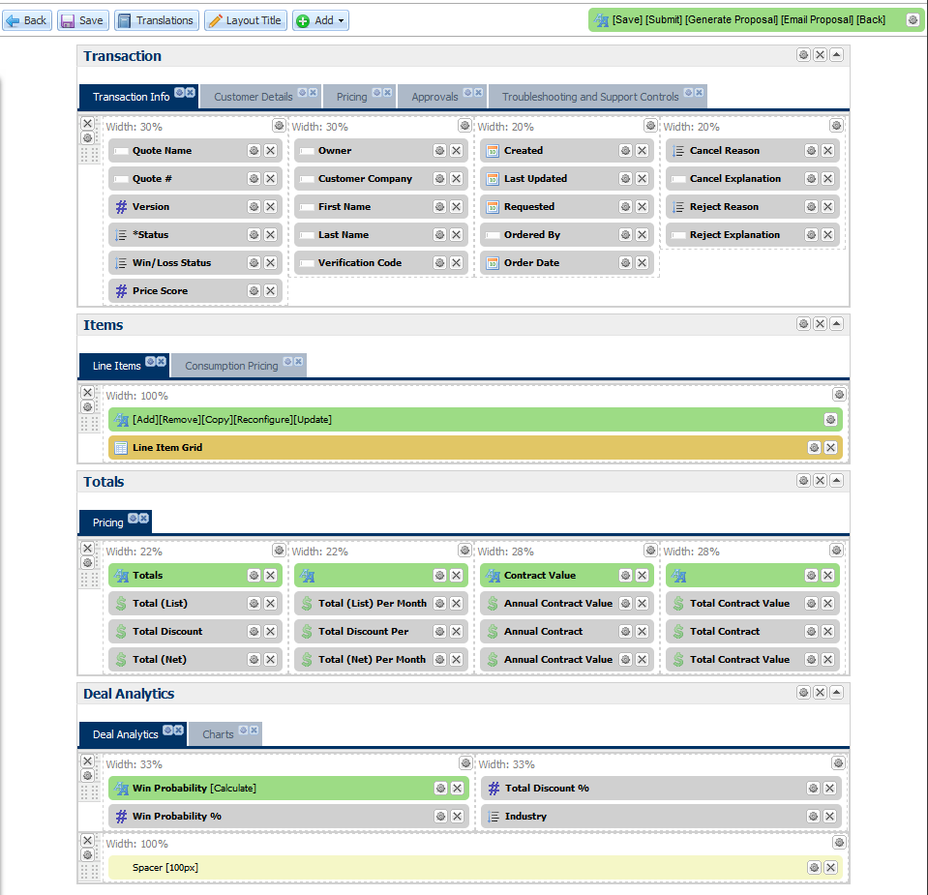

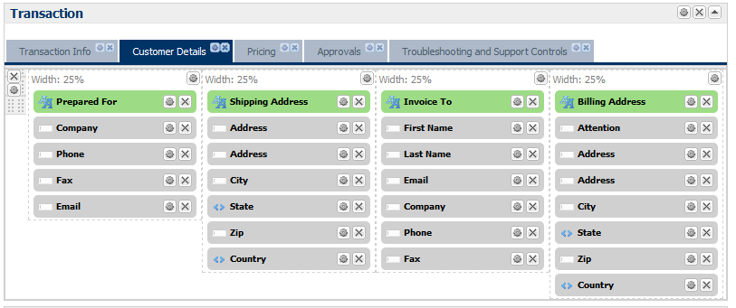

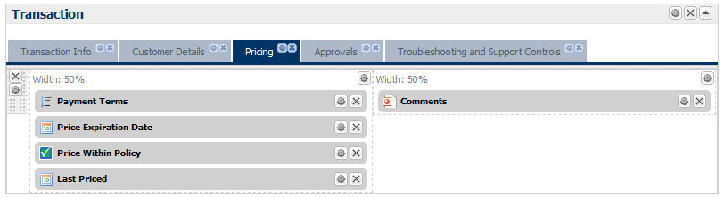

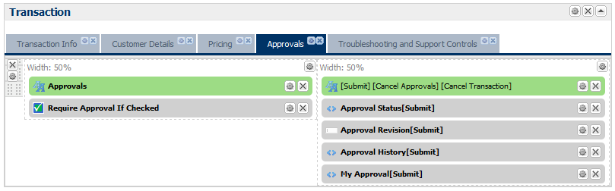

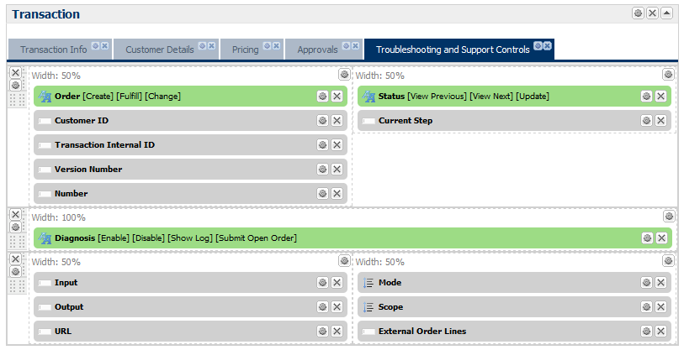

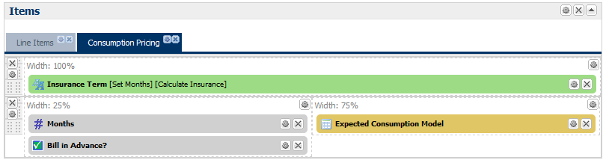

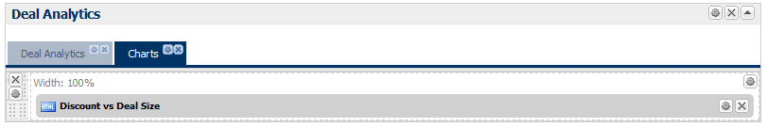

1. Modify columns so that all have 50% label/50% forum input, with the exceptions noted below:
   1. All columns in Summary/Pricing panel: 70%/30%
      1. Add the CSS class “chartcol” to the four columns in the middle row. Add the CSS class “subtotal” to the columns in the third row.
   2. All Columns in Transaction Details and Customer Details tabs as 40%/60%
2. Set ALL toolbars width to 100%, align left, display as Buttons.